WE BELIEVE

- In the Bible as the divinely inspired, inerrant Word of God; the revelation of His mind and will to man; our infallible, all-sufficient guide for salvation and for the Christian life (2 Tim. 3:16-17; 2 Pet. 1:20-21).
- In one God, the Creator of all, eternally existing in three Persons; Father, Son, and Holy Spirit (Gen.1:1; Ps. 90:2; Matt. 28:19).
- In the deity of the Lord Jesus Christ, that He is true God and true man, begotten of the Holy Spirit, born of a virgin, and that He has a perfect and sinless humanity (Luke 1:35; John 1:1, 14; Phil. 2;6-7; 1 John 3:5).
- In the total depravity of the nature of man through his fall in the garden of Eden, and the absolute inability of man to save himself from eternal punishment by his own works (Gen.3; Rom.3:23; Eph.2:8-9).
- In the bodily resurrection of the just and the unjust, the everlasting blessedness of the saved (Rev.21:1-7), and the eternal conscious punishment of the unsaved (Luke 16:22-28; Rev.20:11-15, 21:8).
- In the finished work of Christ on the Cross, through which sacrifice Christ has effected complete and eternal redemption, God setting His seal of approval on the work of Christ by raising Him from the dead, enthroning Him at His own right hand in heaven, and that He is the Head of the Church, the Lord of the individual, the High Priest over the Household of God, and the Advocate for the family of God (Eph.1:20-23; Phil.2:5-11; Col.1:12-19; Heb.10:1-15; 1 John 2:1).
- In the immediate and eternal salvation of every person who truly believes on Christ and by faith rests on His finished work as the only righteous ground on which a holy God can forgive sins (John 6:47; Rom.10:9-13; Eph.2:8-9).
- That all who by faith receive the Lord Jesus Christ as Savior and Lord are born again, indwelt, and baptized by the Holy Spirit into the Body of Christ, the Church, of which He is the risen and ascended Head (Rom.8:1-17; 1 Cor.12:13; Eph.1:22-23; Col.1:18).
- That the early Church met together and “continued steadfastly in the apostles’ doctrine and fellowship and in breaking of bread, and in prayers,” providing a pattern for the Church today (Acts 2:42).
- In the personal, imminent, and premillennial coming of the Lord in the air to rapture (catch up) the Church (1 Thess.4:13-18).
- In the revelation of Christ in glory at His Second Advent to the earth to establish His kingdom on earth and to reign in righteousness (2 Thess. 1:6-10; Rev.19:11-20:6).

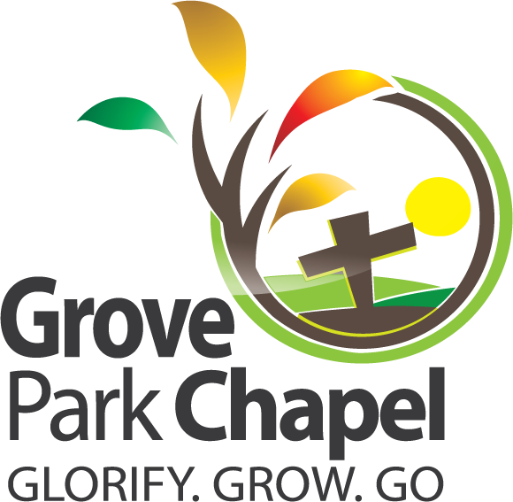

605 Sherron Road Durham, NC 27703
Phone: (919) 596-1152
Email: gpc@nc.rr.com
groveparkchapel.com

152
Email: gpc@nc.rr.com
groveparkchapel.com
We exist to glorify God through worship and service as we grow believers to spiritual maturity and go out to show God’s love
and share Christ with others.
Glorify. Grow. Go.

January 11, 2026 11:00 am

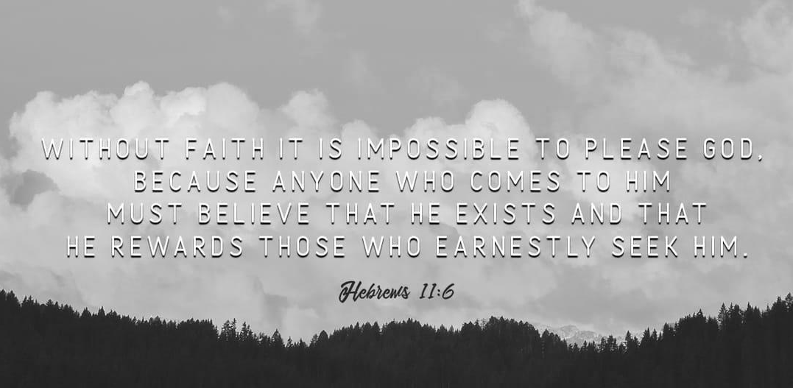
Worship Service
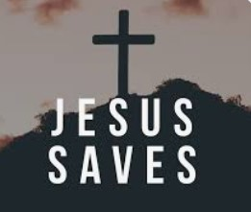
Opening Meet and Greet ....………..............................Cliff Detweiler

Worship Song……………..Chorus #18 “He Has Made Me Glad” (2x)
Announcements………………….…………………….…... Dale Brooks

Worship Songs……………..………….…... #495 “Jesus Saves!” (1,4)
#269 “Nothing But The Blood” (1-2)
Chorus #227 “Turn Your Eyes Upon Jesus” (2x)

Special Video….…………………………..….............“Mighty To Save”

Message from the Word………..……..………..................Dale Brooks

Closing Song……....…………………….…...#306 “Just As I Am” (1-2)

Closing Prayer.............................................................. Cliff Detweiler

THIS WEEK’S SCHEDULE OF SERVICES AND ACTIVITIES:
January 12th – January 18th

Monday 12th 5:00 pm 3M
Wednesday 14th 6:00 pm New Year’s Celebration
Sunday 18th 9:00 am Lord’s Supper
10:00 am Sunday School
11:00 am Worship Service & SONshine Zone
5:00 pm Choir Practice

January Memory Verse

“It is written, ‘Man shall not live by bread alone, but by every word that proceeds from the mouth of God.’”

Matthew 4:4, NKJV

Tithes and Offerings
Welcome to Grove Park Chapel!

We hope you enjoy the services.
For anyone who wishes to contribute to this ministry, the box on the wall in the foyer is for that.

purpose.



ANNOUNCEMENTS

New Year’s Celebration

Come join us this Wednesday, January 14th as we look forward to the new year. Pot luck dinner begins at 6:00 pm. Service will end with observing the Lord’s Supper.



Christmas Card Mailbox
There are still some Christmas cards out at Inspiration Station. Don’t forget to stop by after the service to see if you have any waiting for you!

2025 Giving Receipts
2025 giving receipts will be available for pick up later this month.


January:

We are collecting the following shoebox items for this month: coloring books, crayons, pens,
and other school supplies.
Thank you for giving to this amazing ministry.

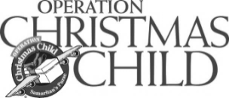

Submissions for bulletin announcements must be turned in to the office
no later than 5:00 pm each Wednesday. Thank you!
Submissions for bulletin announcements must be turned in to the office by each Wednesday at 5 pm. Thank you!

